IOT Case Study Report

1. Introduction to IoT Network Simulation
The Internet of Things (IoT) is fundamentally a system of physical objects equipped with embedded software, network connectivity, and sensors that allow them to continuously gather and share information. To understand how these networks operate without needing expensive physical hardware, engineers often use Cisco Packet Tracer. It serves as a robust simulation environment perfect for visualizing how smart buildings and homes function on a network level. This report explores two different network setups: a comprehensive multi-device network managed centrally, and a simpler smartphone-controlled home environment.


2. Case Study 1: Enterprise IoT Network Topology
This first scenario illustrates a larger-scale, commercial IoT environment where a wide variety of smart devices are linked together via a central Wireless Access Point (AP) or network switch. This type of setup mirrors what you would find in a modern smart office, where monitoring, automation, and security are handled on a single integrated network.

Architecture and Components
The architecture utilizes a Star Topology, meaning every single smart device communicates directly with a central networking node. This central node routes information to a dedicated management server or PC, which acts as the control brain for the entire system.
The hardware distributed across this virtual workspace includes:
- A central Access Point/Wireless Router to anchor the network.
- Security hardware, including an IP Camera for remote surveillance, a Smart Door Lock, and a Motion Detector to trigger alerts.
- Safety monitors like a Smoke Detector/Fire Alarm.
- Environmental controls, including Humidity and Temperature sensors, alongside Smart Light Bulbs.
- A Management PC that an administrator uses to configure and oversee all connected hardware.
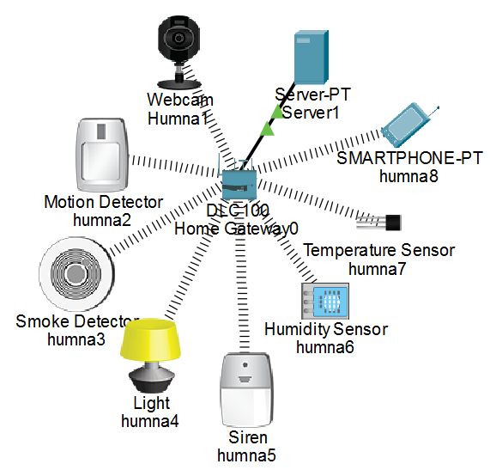

Communication and Automation Flow
Devices on this network receive their IP addresses either manually (statically) or automatically via DHCP. Administrators use the IoT monitor inside Packet Tracer to write logic-based scripts that automate the environment.
For example, the communication flow for a security event looks like this:
- The Motion Detector registers activity and fires a signal to the main router.
- The router pushes this data to the central IoT Server/Management PC.
- The server processes the pre-written script and sends out immediate commands.
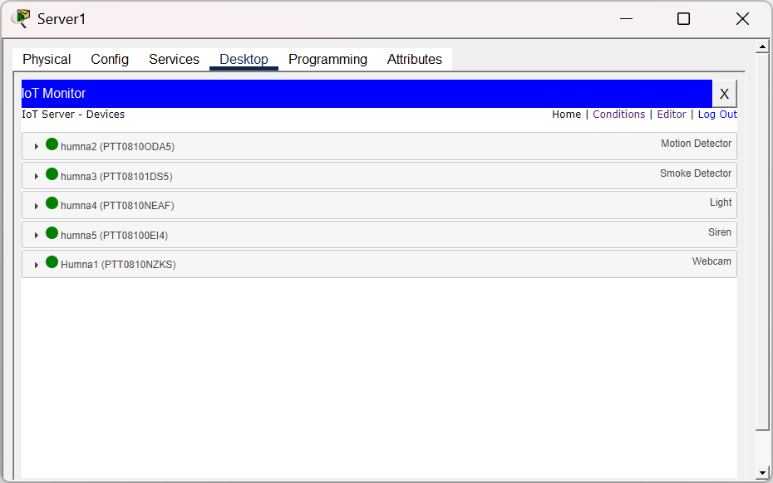
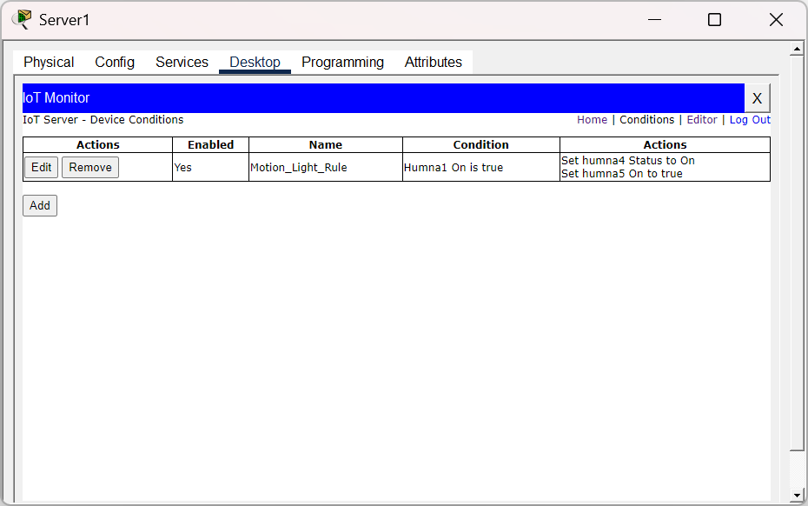
- Consequently, the Smart Lights turn on, the Smart Door Lock engages, and the IP Camera starts streaming video to the server.
This enterprise setup is incredibly scalable for campuses and commercial buildings because administrators can easily attach new hardware and manage everything from a unified terminal.

3. Case Study 2: Smart Home via Smartphone
The second scenario shifts focus to a consumer-level residential environment. Here, everyday household appliances communicate with a single Home Gateway, and the homeowner manages everything remotely via a smartphone app.

Architecture and Components
Instead of a complex server, all five smart devices (a Ceiling Fan, Air Conditioner, Light Bulb, Window, and Garage Door) connect wirelessly to a Home Gateway. This gateway is a hybrid device that acts as both the Wi-Fi router and the IoT server.
The user simply connects their smartphone to the same Wi-Fi network and accesses a web-based dashboard on the gateway to control the appliances. The command travels from the phone, over the 802.11 Wi-Fi protocol to the gateway, which then pushes the command to the specific appliance.
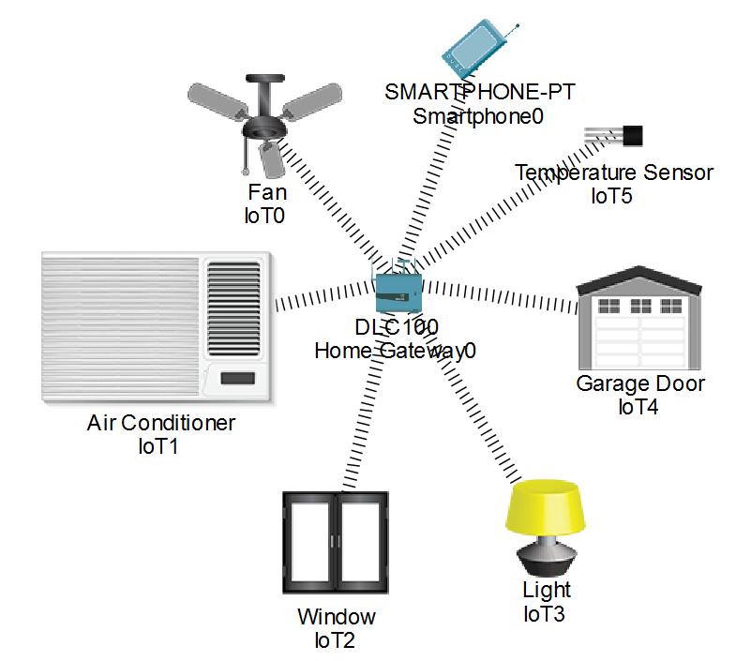

Automated Temperature Control
While most controls in this scenario are manual (like opening the garage), it also features an automated environmental trigger. The system continuously monitors room temperature; if it rises above 30 degrees Celsius, the Home Gateway automatically powers on the Air Conditioner without the user having to touch their phone.
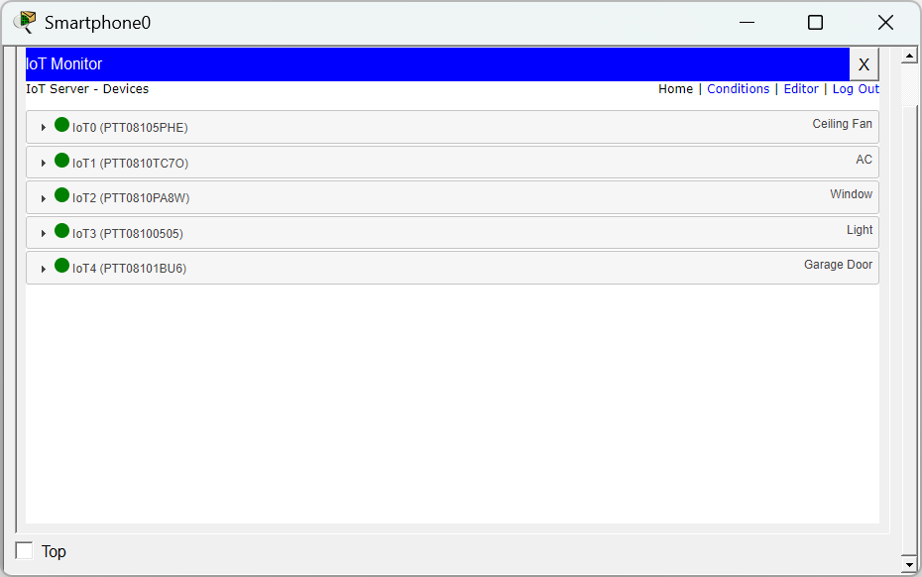
This residential setup is highly cost-effective, energy-efficient, and user-friendly, making it ideal for standard consumers who want remote access to their home without managing complex infrastructure.
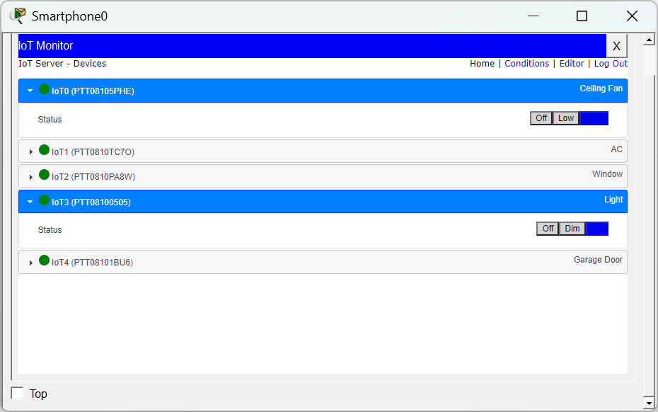
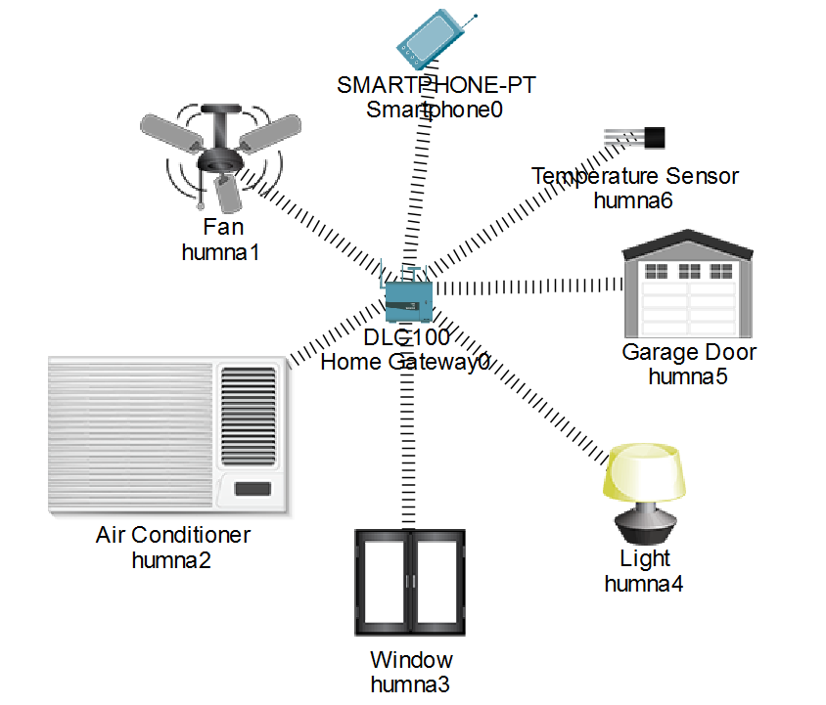

4. Implementation Challenges and Best Practices
While simulating and deploying these networks, engineers face several practical challenges:
- Security Vulnerabilities: Because these devices rely on Wi-Fi, the traffic can be intercepted if the network is not properly encrypted. Furthermore, leaving default passwords on hardware, especially things like IP cameras, exposes the network to unauthorized access.
- Software Limitations: While powerful, Cisco Packet Tracer has a cap on how many automation rules can run simultaneously and does not natively support specific real-world protocols like Zigbee or MQTT.
- Hardware Capacity: A standard Home Gateway (like in Case Study 2) has a limited processing threshold; connecting more than ten devices can cause network performance drops.

Recommendations for Deployment
To secure and optimize these environments, it is highly recommended to update all device firmware regularly to patch vulnerabilities and to isolate all smart hardware on its own dedicated IoT VLAN. For wireless transmission, networks must utilize WPA2 or WPA3 encryption. Finally, for enterprise setups similar to Case Study 1, deploying lightweight communication protocols (like MQTT over TCP) ensures the network remains fast and efficient as more devices are added.

